PUNTO 2

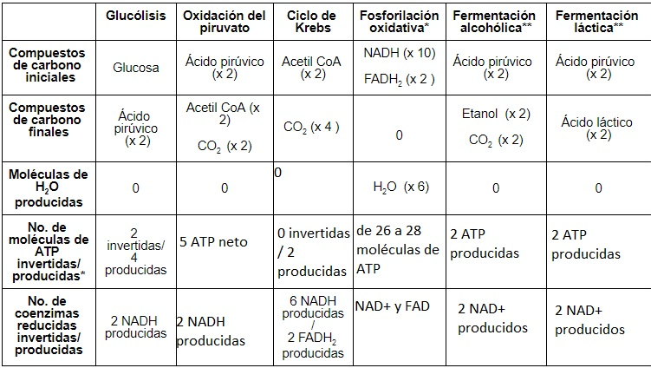

Referencias:

Recuperado de: https://es.khanacademy.org/science/biology/cellular-respiration-and-fermentation/oxidative-phosphorylation/a/oxidative-phosphorylation-etc

Recuperado de: https://es.khanacademy.org/science/biology/cellular-respiration-and-fermentation/variations-on-cellular-respiration/a/fermentation-and-anaerobic-respiration

D. E. Sadava, D. M. Hillis, H. C. Heller, and S. D. Hacker, *Life : the science of biology TT  -*, Eleventh e. Sunderland, MA : Sinauer Associates